Tolerating Uncertainty in 2019

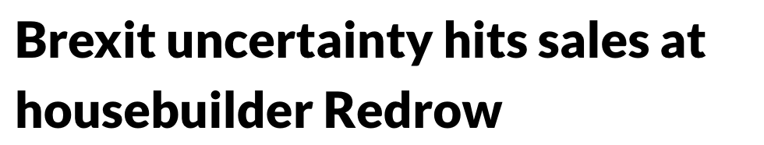
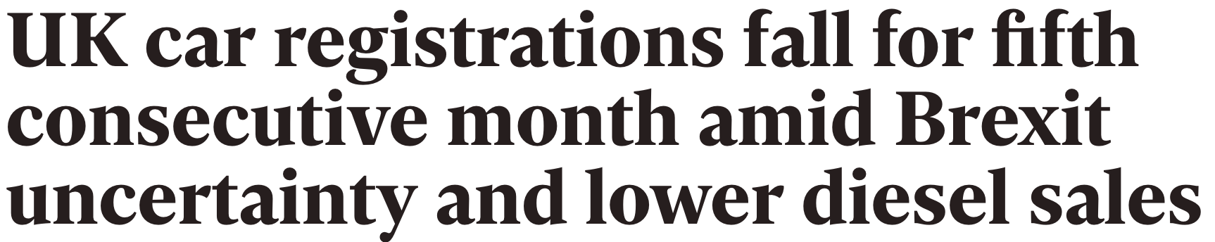
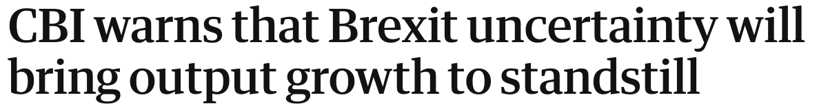
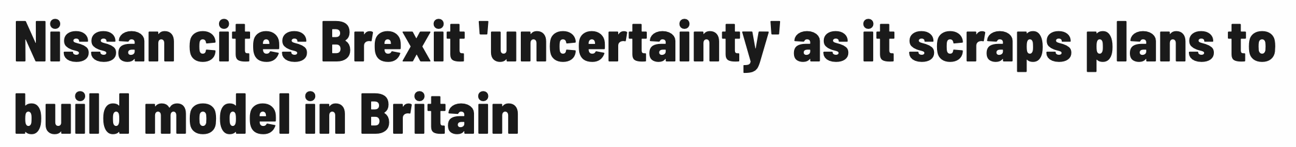


Whichever side of the ‘Brexit’ debate you sit on, one factor unites us all; uncertainty.

None of us, no matter how educated or informed, can accurately predict the outcomes of whatever political decisions are made this year, and that leaves us with a lack of clarity.

For some, intolerance of uncertainty can be debilitating; leading to catastrophic thinking, rumination over worse-case scenarios, heightened anxiety and an inability to move forward.

So, what can we do to maintain progress when there are no clear answers?

Increase certainty? Or increase tolerance of uncertainty?

Uncertainty is a part of life. Whether the source is political, financial, health-related, environmental, or from any aspect of life, one thing’s for sure – get rid of one uncertainty and another will soon take its place. By searching for certainty, we inevitably decrease our tolerance of the uncertain.

Ever experienced some unusual medical symptoms knowing it will be at least a week before you’ll get to see your GP? Did ‘Googling’ the possible outcomes help to alleviate any fears, or just fill your head with even more things to worry about? (I bet you did more searching for the worst outcomes than the better ones!) Did it change the outcome?

Digging for answers in an uncertain world only increases our level of worry and procrastination, so what’s the alternative?

Increasing our tolerance of uncertainty.

But surely this is negligent? Fool-hardy? Irresponsible?

Tolerating uncertainty shouldn’t be confused with ignoring it; it simply means relinquishing the search for absolute certainty, in a world where it simply doesn’t exist.

Tolerating uncertainty doesn’t mean doing nothing, but it does involve changing your actions.

How?

Behaviours like putting things off, avoiding decision-making or constantly seeking reassurances only help us find temporary relief from the discomfort of uncertainty; what we need is a shift in our thinking.

The good news is, that in the same way we can train our bodies to be stronger and fitter, with practise we can train our brains to think differently too.

Our thoughts carve tracks through our mind (neural pathways), and the more we repeat a thought or behaviour, the deeper the path is cut, and the easier and more automatic it becomes to follow. Treading new paths requires conscious effort, emotional intelligence and determination.

Next time you experience the symptoms of uncertainty anxiety, instead of following automatic, deeply carved and often unhelpful thoughts, allow brain to try a new route:

- Notice your anxiety; name it; and allow yourself to look at it from the shoes of someone who is known for not playing it safe
- Examine the evidence: scrutinise your data, chuck out conjecture and make decisions on proven facts
- Set aside time to explore the opportunities rather than the threats
- Sort the ‘can controls’ from the ‘can’t controls’ and focus your attention on the things you can influence
- Go with your gut, but have a contingency plan
- Ask others what they would do to expand your range of possible options
- Determine the chances of certain things happening and assign your attention accordingly; 1% chance, 1% of your attention

It helped? Then do it again, and again…. and relish your new skill for more agile and flexible thinking!

At CoDevelop we love helping others to develop more resourceful ways of thinking and behaving. Contact us to discuss how we can support you or your business tread new and better pathways.

