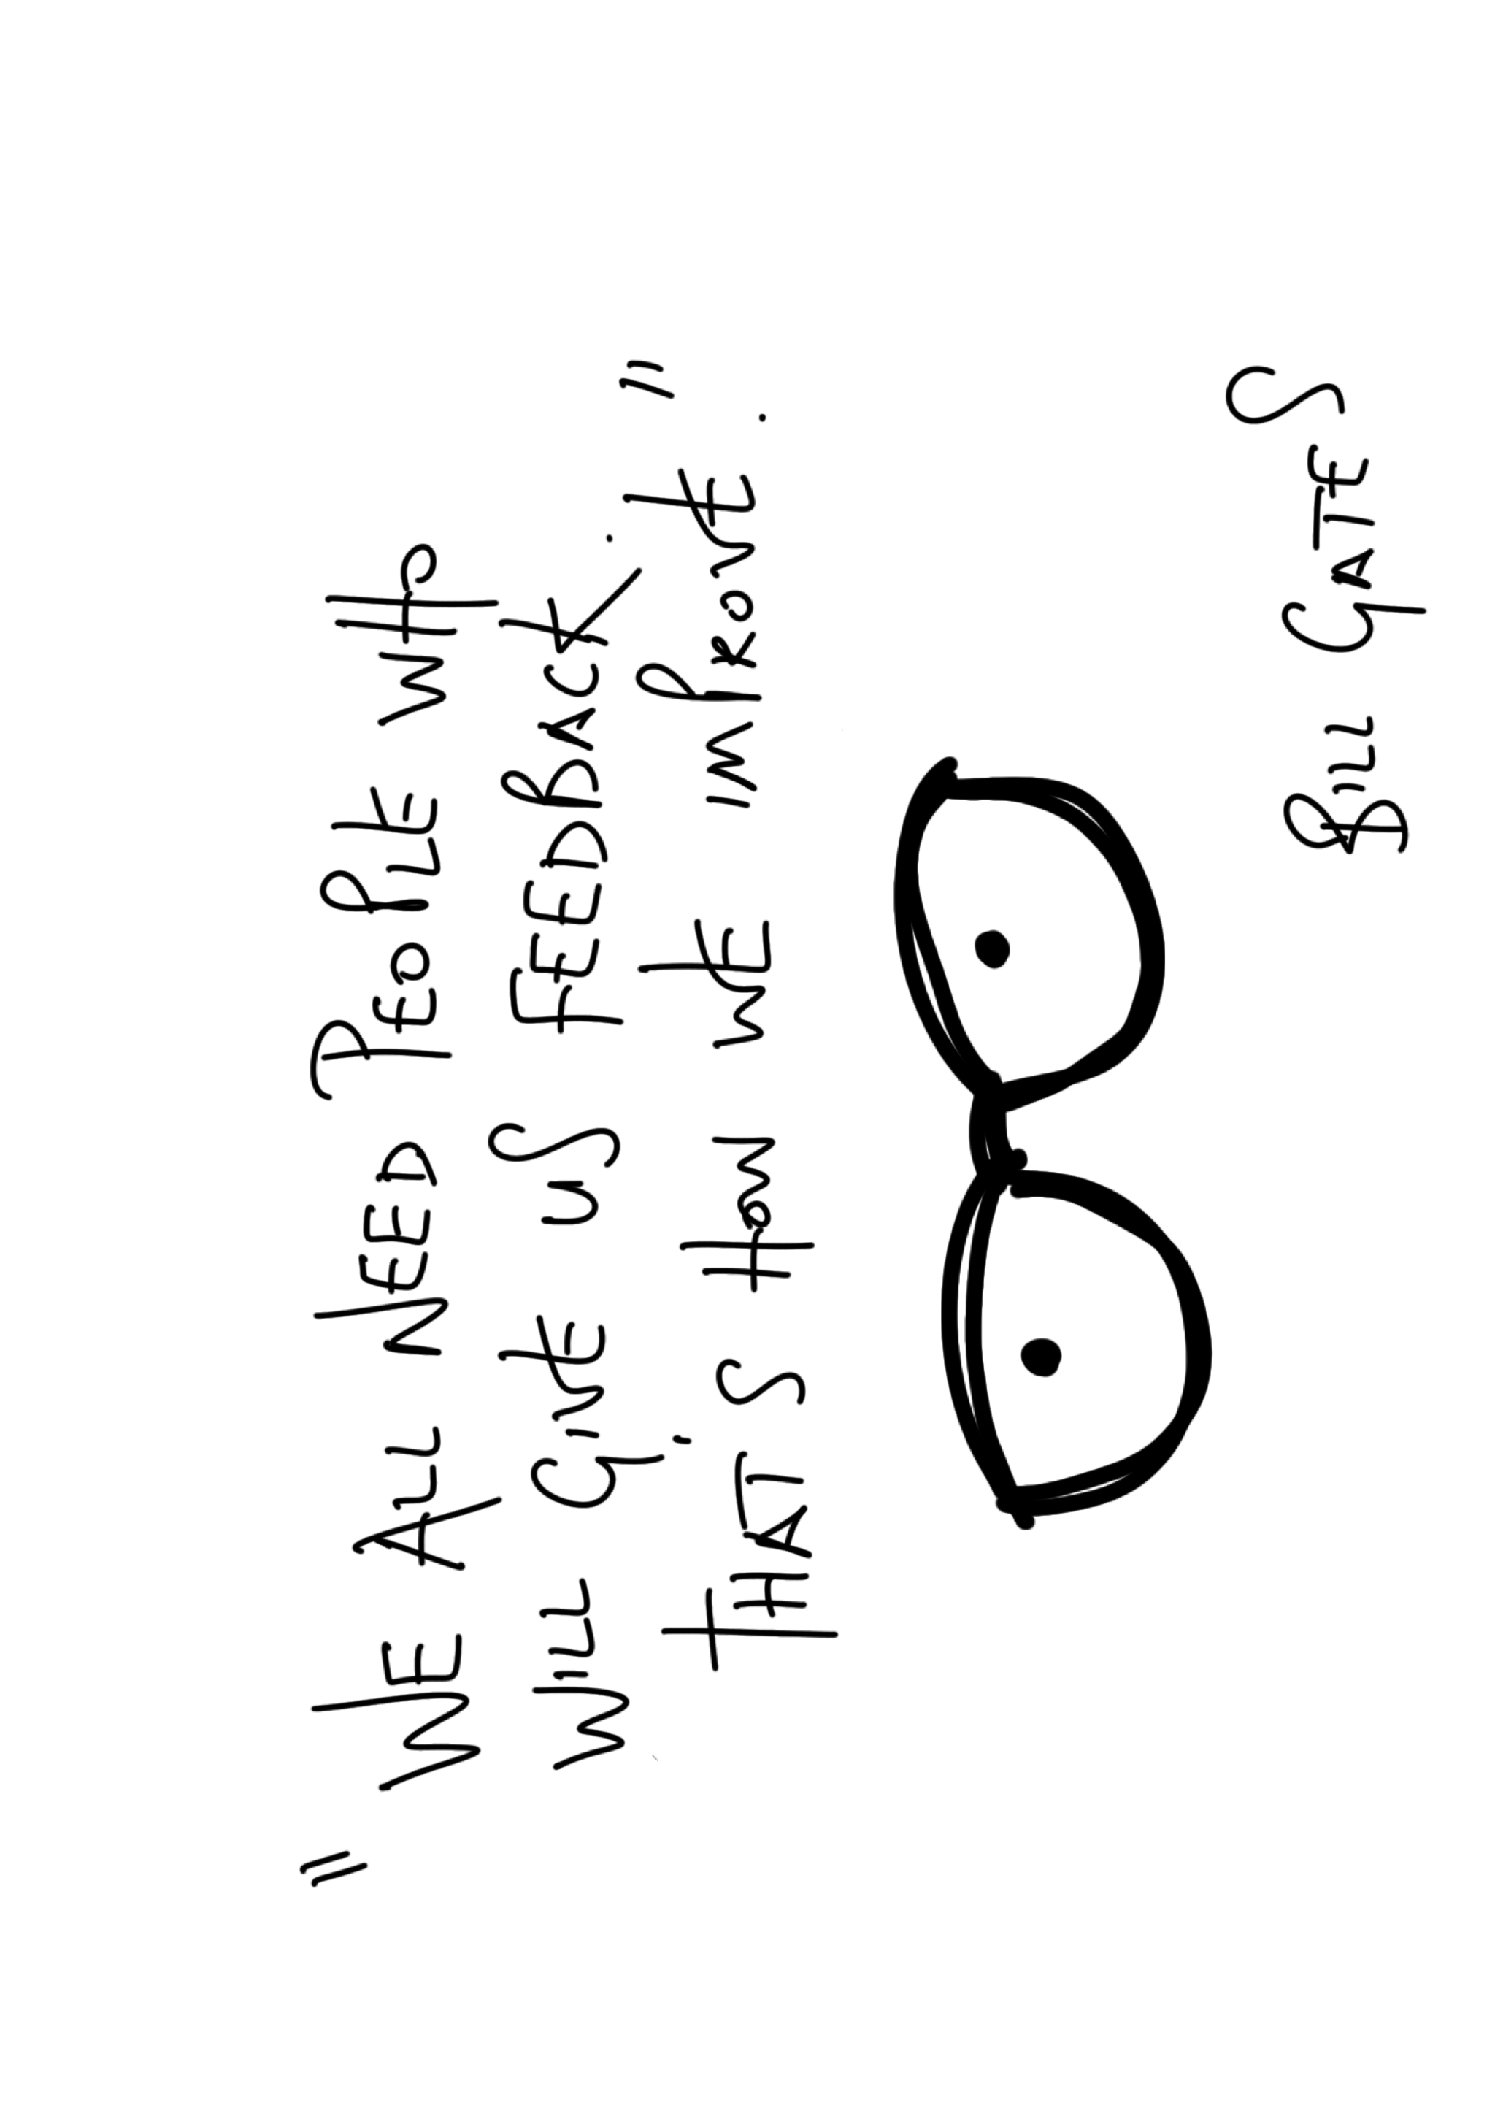
Why give or receive feedback?

Done badly, the thought of giving or receiving ‘feedback’ sends shivers down the spine. Contrary to some people’s beliefs and practises, feeding back shouldn’t be a forum for pointing out flaws, dwelling on mistakes or demonstrating that we know best.

Why is it that, as they grow, we readily and regularly heap praise and encouragement on our kids, and even our pets, with a focus on effort and achievement rather than failure, yet when it comes to work we often only engage when something has gone wrong? It’s no wonder then that ‘feedback’ is regularly demoted to a stand-alone, once a quarter chore that both parties dread.

Done well, feedback encourages growth, resourcefulness, daring, passion and trust – key qualities for high performing teams.

At Co-Develop, we agree with Karen Naumann (Organisational Psychologist) writing in the Huffpost, that well-delivered feedback is ‘sometimes the last push you need to build up the courage to do something outside of your comfort zone, or to do what you have believed you couldn’t do.’

The gift that keeps on giving

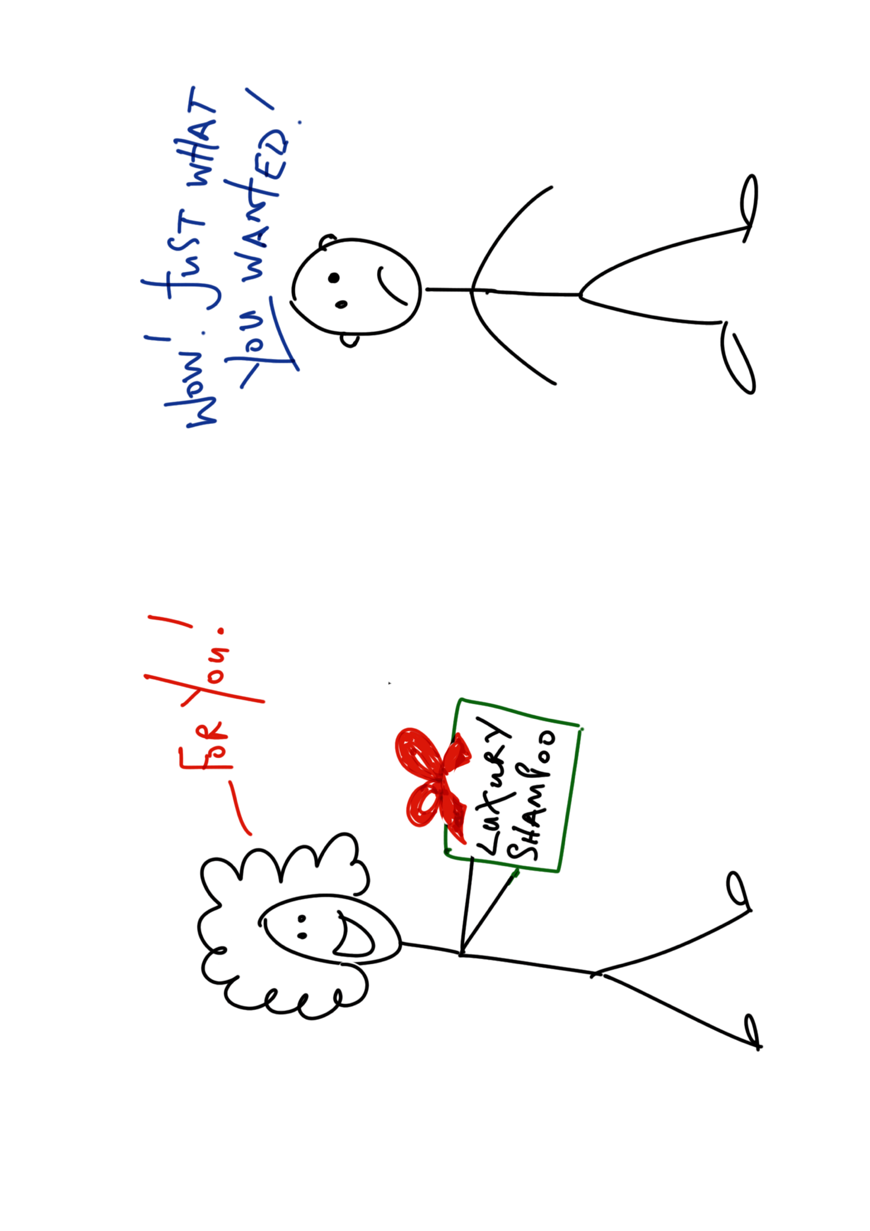

It’s not unusual for ‘feedback’ to be regarded as a ‘gift’, but all too often only by the giver! Get it right, and both parties benefit. The internet is awash with articles detailing the do’s and don’ts of effective feedback (268,000,000 results in 0.49 seconds), so what are Co-Develop’s ‘Top Tips’ for ensuring feedback is given and received in a way that strengthens relationships, builds trust, and develops high performance?

Top Tips (for gifts or feedback!)

Giving:

- Tailor it to the recipient: think about what works for them; what do they most want or need? What will help them achieve their aims, as well as yours?

- Include the instructions and the batteries: be clear about what you’re giving and why; help the recipient understand how the feedback might be used; it may not be as obvious as you think. And make sure you give them the equipment they need (knowledge, skills, resources) to be able to make use of it.

- Handle with care and wrap it beautifully; it’s not always the quality of the gift that has the biggest impact, but the manner in which it’s offered.

- Don’t save it just for birthdays and Christmas: it’s the small, thoughtful and unexpected gifts that often bring the most delight.

- Keep the receipt: don’t assume that you’ve provided the perfect gift; look out for signs that it’s not quite what they wanted or needed and be prepared to swap it for something else; or just accept that you got it wrong and they have shoved it in a drawer! Try again.

- Give with a kind heart: even if the gift isn’t what you’d hoped to be able to give (perhaps you have to share some disappointments about performance), focus on the positives.

Receiving:

- Keep it in perspective: so, you got one duff gift, that doesn’t take away all the wonderful ones you’ve received over the years

- Drop hints: let people know what feedback you’d like and how you’d like to receive it

- Receive with a kind heart: even if they got it horribly wrong, this person has taken the time and effort to give you something that they thought you might need or want

- Tell them what you think: if it’s the wrong size or colour, let them know; better that you are both happy with the outcome

- Evaluate: not all feedback is equal; sometimes it’s the thought the counts; and other times it’s fine to be grateful for the gift, knowing it’s going straight to the charity shop in the morning!

If you need any help in giving or receiving feedback, or training others in the art of this exchange, please drop us a line.

